# CALIFORNIA STATE UNIVERSITY, NORTHRIDGE

**Department of Electrical and Computer Engineering**

# ECE 526L

# LAB – 8: Register file modelling.

Written By: Raj Kumar

### Introduction:

### In this lab we will create a Register file model by using Synopsys VCS on Linux OS environment and different terminal commands.

### Methodology: It is being familiar with the Linux and Synopsys VCS that will navigate your system using terminal. Now to write a Verilog code for the module using a text editor. Use Linux based text editors and the file should have “.v” extension.

### In this lab, we will create a register file that will be used as a random-access memory. Use parameters for both width and depth in our models and for the ram and create a Verilog model of a register file with the following specifications. Now, save as “ram.v”.

### The module name and file name should be consistent.

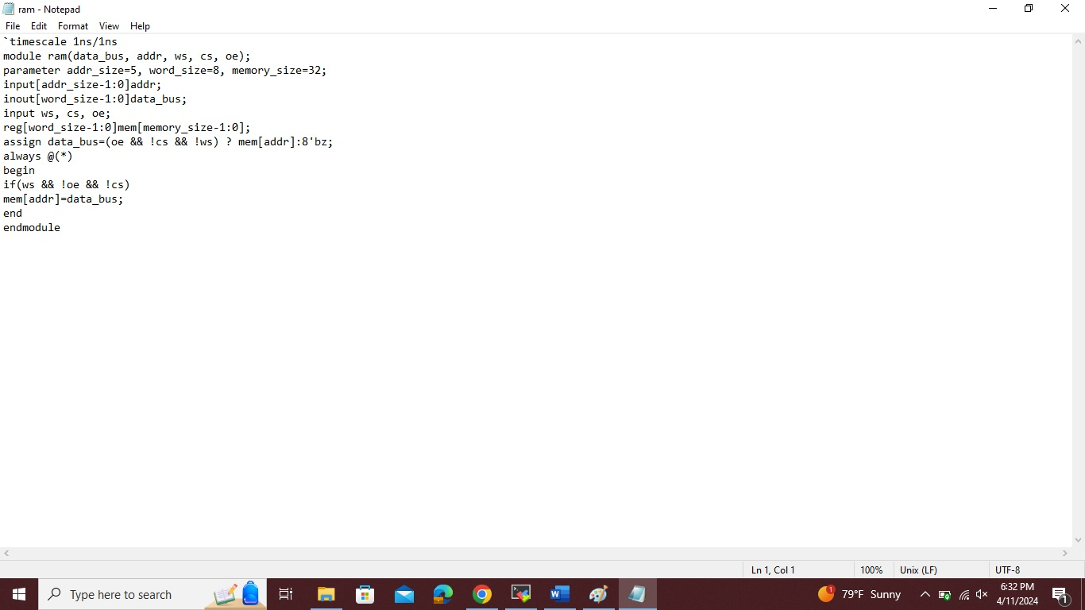

This is the image of **“ram.v”,** store it in new file, also in folder **“Lab8”.**

We will create a second model that has no write capability to be used as **read only memory (ROM)**. Verilog system tasks **$readmemb** and or **$readmemh** will be used to set values in the module.

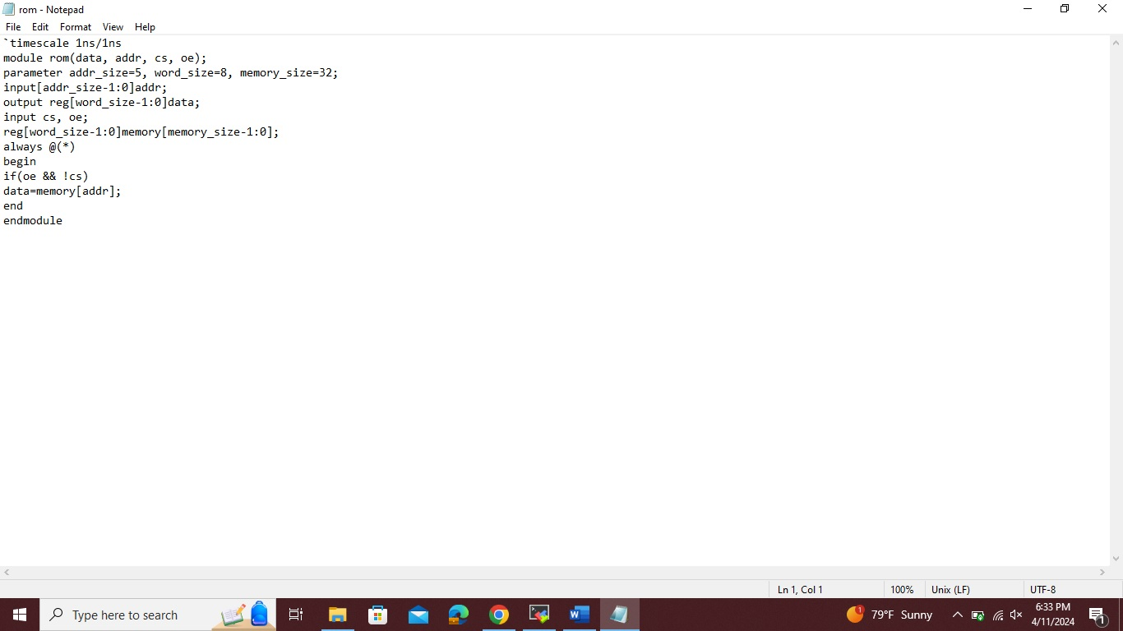

#### The above image is of “rom.v”.

#### We create a verilog testbench for the ram.v, it must do the following things as per the instructions and save it as “ram_tb.v”.

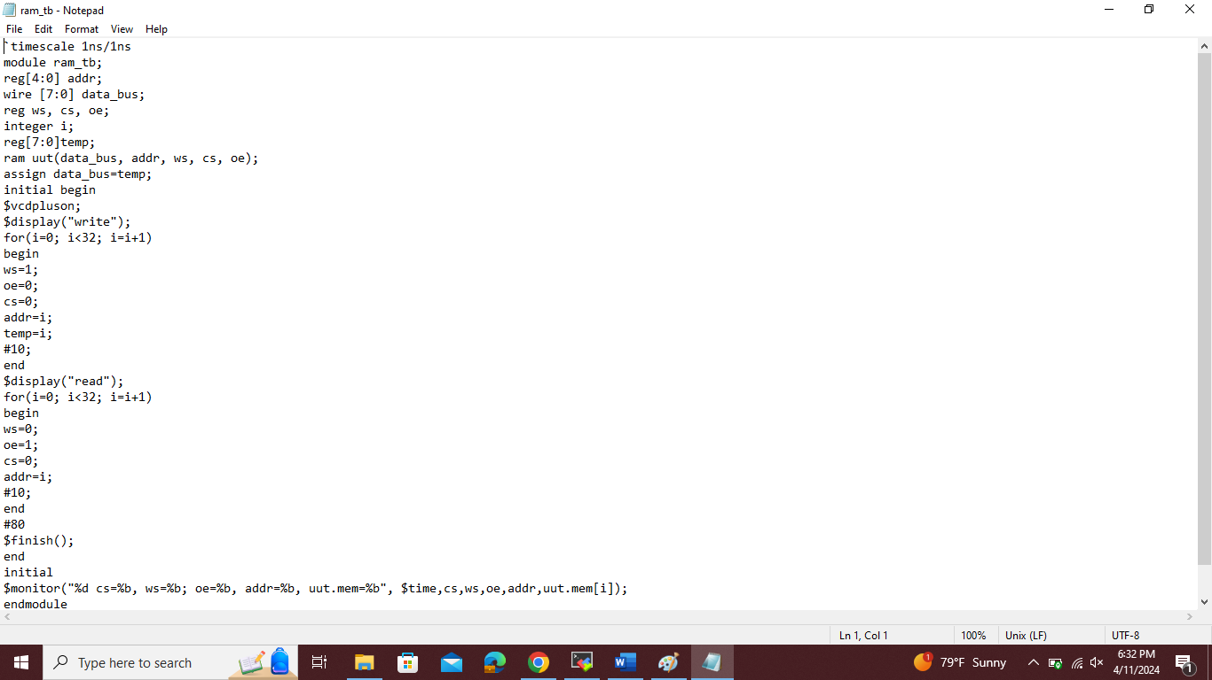

This above image is of **“ram_tb.v”**.

Then use the command as follows: **“vcs -debug_access+all ram.v rom.v ram_tb.v ”**.

If we don’t see any error messages if everything is type correctly then output should look like below figure.

## simv:

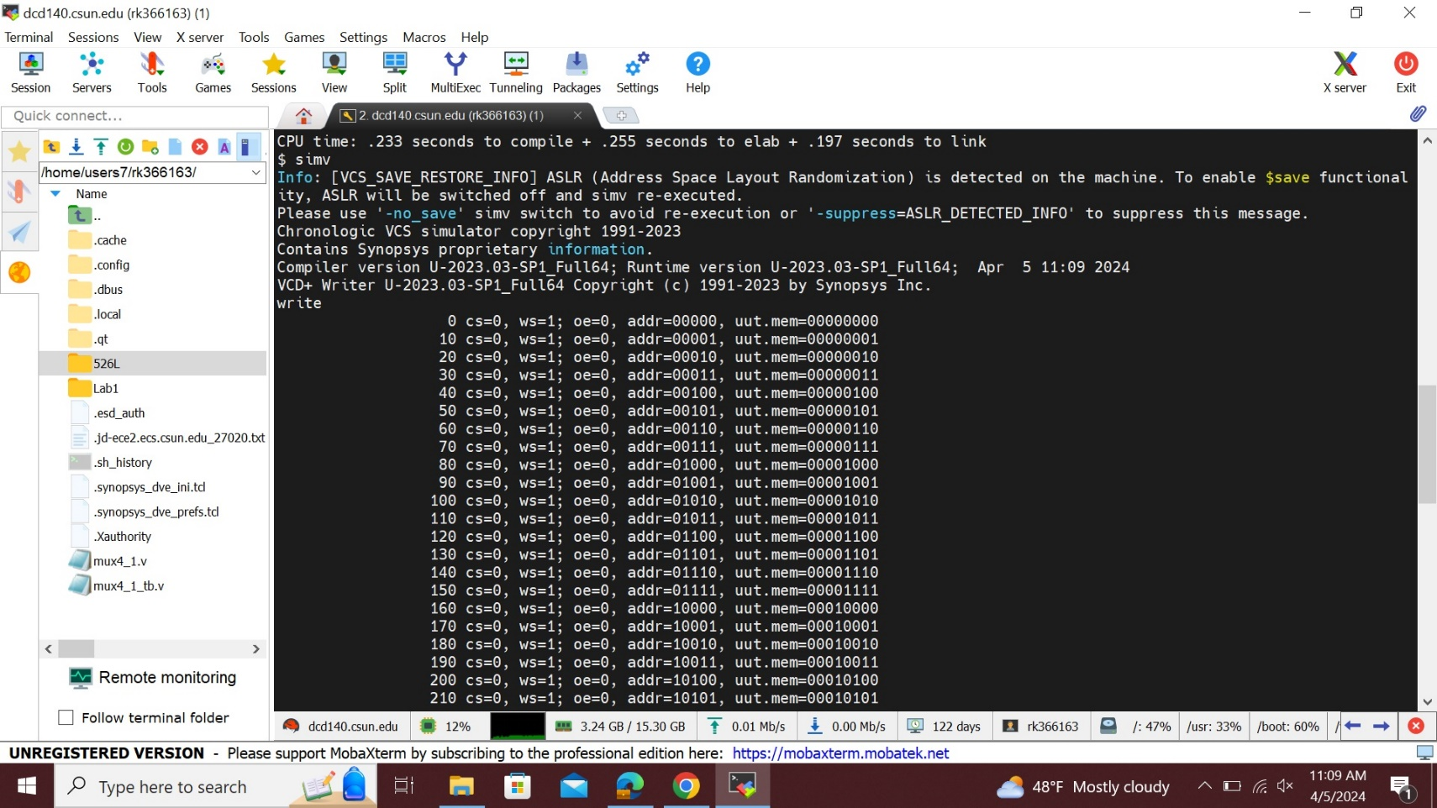

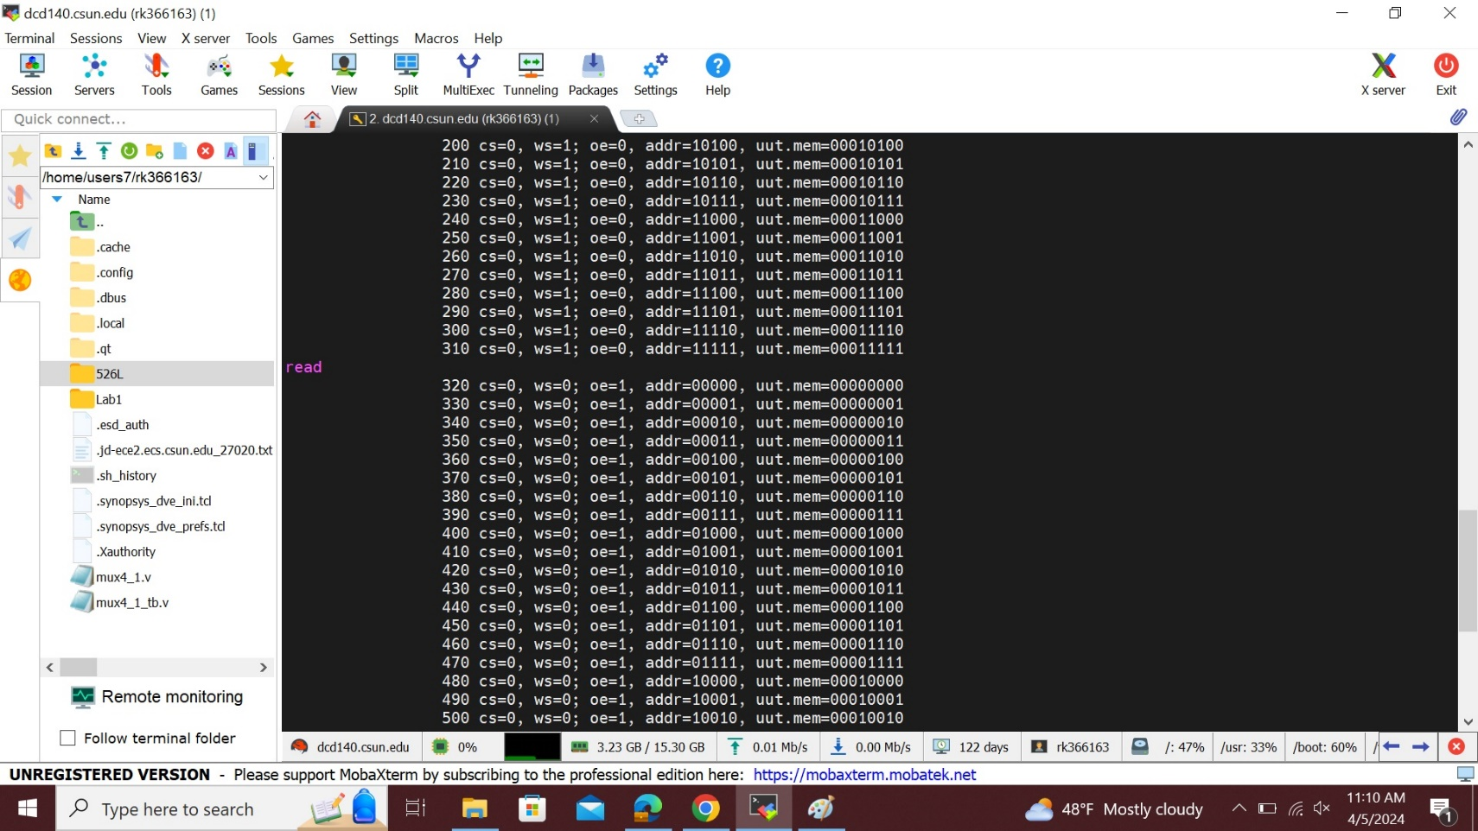

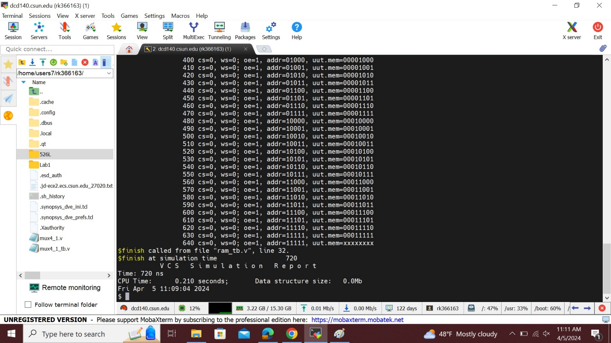

To see the wave form first type **“dve”** command line then we will get the blank simulation window then go to file and open database then choose **vcdplus.vpd** and open the file.

Then finally select all the signals with the mouse, then right click and select to   
**“add to wave->new wave view”**.

Then we will get the waveform as shown in below image;

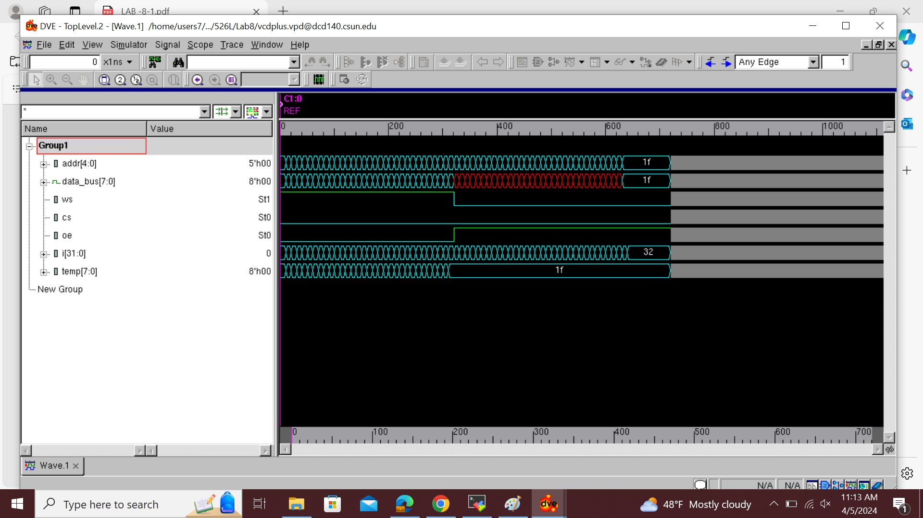

Now we should create a testbench for rom based on the instructions given and save it as **“rom_tb.v**”.

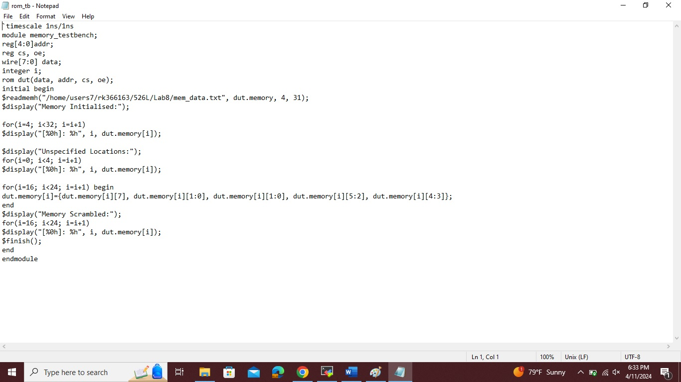

Then use the command as follows: **“vcs -debug_access+all ram.v rom.v rom_tb.v”**.

If we don’t see any error messages if everything is type correctly then output should look like below image;

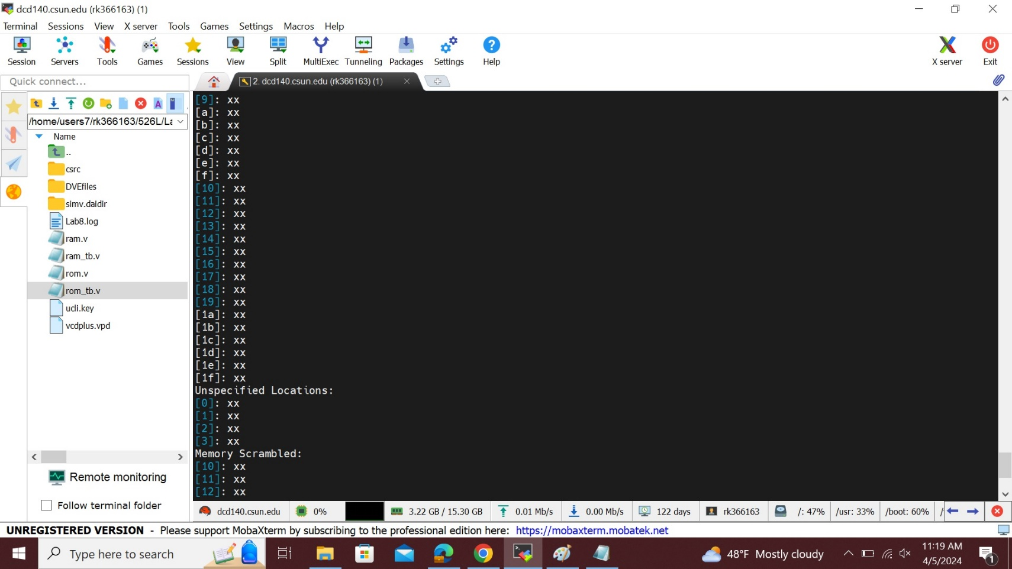

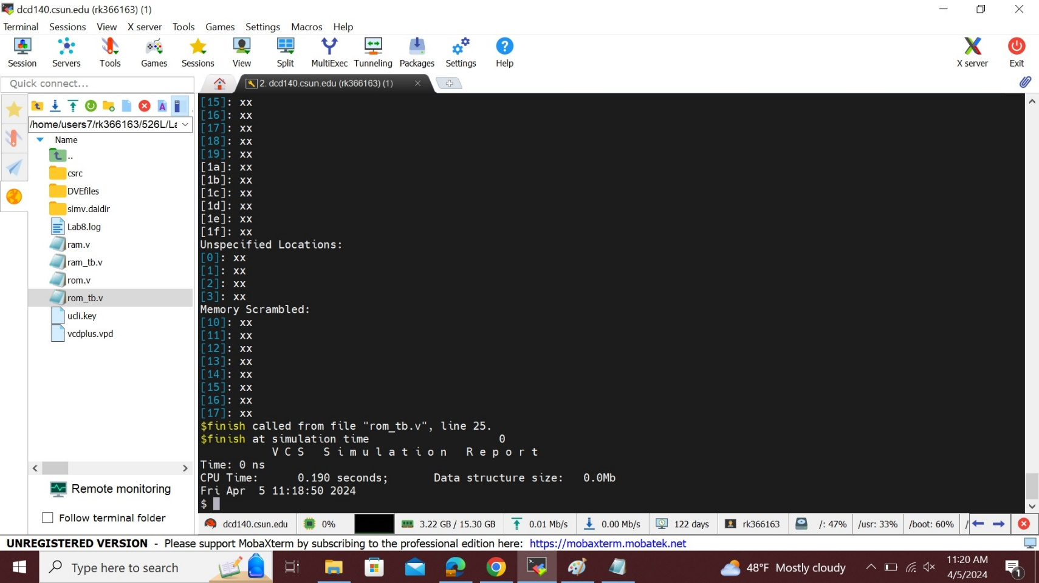

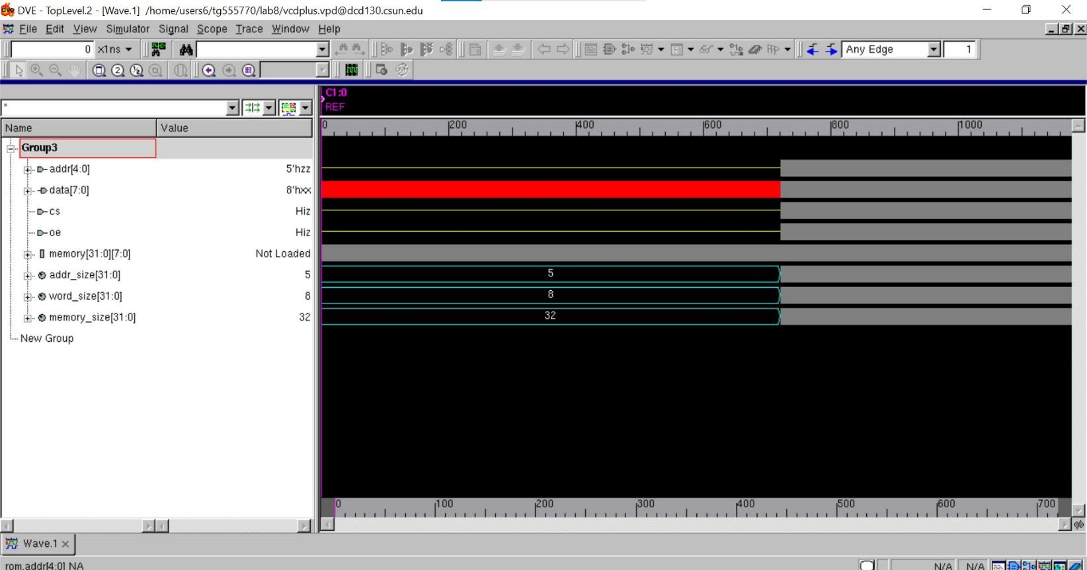

This is the image of the wave form for “**ram.v**”.

## Analysis of result:

## The answer explains the design and implementation of a Verilog register file that serves as a random-access memory (RAM). It has a five-bit address bus, a bidirectional data bus, active low chip-select (cs), active high output-enable (oe), and a write strobe (ws) for writing data to memory. In order to verify enabled and disabled states, read and write to every memory address, show individual and block reads, and output a walking one’s pattern to test the independence of each output bit, a separate Verilog testbench is constructed. Using the $readmemh system task, a different testbench initializes the memory with values, shows that initialization was successful, jumbles the bytes in the designated memory locations, and prints the contents of every memory location.

**Conclusion:**

In conclusion, the Verilog modeling of a register file using Synopsys VCS on the Linux operating system has provided valuable insights into digital design and simulation methodologies. Through this project, we gained a deeper understanding of the hierarchical structure of a register file, its functionality in data storage and retrieval, and the implementation of such a design in a hardware description language.

The process involved writing Verilog code to define the register file's behavior and interfacing it with testbenches to verify its functionality. Synopsys VCS served as a reliable tool for compiling and simulating the Verilog code, allowing us to perform extensive testing and validation.

Throughout the project, we encountered challenges such as ensuring proper data integrity, managing clock cycles for synchronous operations, and optimizing the design for performance and resource utilization. By addressing these challenges, we were able to develop a robust and efficient register file model.

This experience has not only enhanced our Verilog programming skills but also provided practical exposure to industry-standard tools like Synopsys VCS. It underscores the importance of rigorous testing and verification in digital design projects, paving the way for future advancements in hardware design and simulation.

Overall, the successful completion of this lab report signifies a significant milestone in our understanding of register file modeling and its application in digital systems design.

## Lab Questions:

**1.** How many edge constructs do you use in your models? why that is best answer for this design?

**Ans.** The number of edge constructions (such as {always @(posedge clk)} or comparable ones) in your design is determined by the particular needs of your design. Since this is a basic testbench without a timed process, we are not using any in this example. The quantity and kind of edge constructs in a real-world situation rely on things like clock domains, the necessity for synchronization, and the kind of signal processing (combinational or sequential).

I hereby attest that this lab report is entirely my own work. I have not copied either code or text from anyone, neither have I allowed nor I will let anyone to copy my work.

Name(printed): Raj Kumar

Name(signed): Raj Kumar

Date 04/11/2024